ASSIGNMENT # 1: OBJECT ORIENTED PROGRAMMING

**HOSPITAL MANAGEMENT SYSTEM**

**SUBMITTED TO:**

DR. XYZ

**DATE:**

02-April-19

**SECTION:**

XYZ

**SUBMITTED BY:**

XYZ - ID

**CASE STUDY - HOSPITAL MANAGEMENT SYSTEM**

A new hospital is seeing an increase in the number of their patients. They want to create a software system that manage their employees and patients. A part of their software requirement is given below. You also are required to do a self-study on how the out-patient departments of hospitals function and create a design for managing the department.

# **PROBLEM ANALYSIS:**

**REQUIREMENTS:**

1. Hospital containing people that can either be patients or staff members
2. Staff members work in shifts of 8 hours per day with every staff member working in one shift only.
3. Each day, the first shift begins at 7am
4. Staff members can be either administrative, operations or technical.
5. Every staff member has to mark his attendance when he arrives.
6. Administrative Staff Member is responsible for registering patients and maintaining record of the patients in the waitingQueue anf finally generating bill for them to pay.
7. Operational Staff Member is responsible for getting the patient checked and diagnosing his disease
8. Technical Staff Member is responsible for finding and fixing defects in the machines on site
9. At any point in time, the system should be able to display details of staff members of the ongoing shift and patients in the hospital.

**LIST OF CLASSES:**

* Hospital
* Person
* Patient
* StaffMember
* Shift
* AdministrativeStaffMember
* OperationalStaffMember
* TechnicalStaffMember
* Machine

# **FUNCTIONAL DESIGN:**

**LOGICAL FLOW:**

StaffMember arrives at his shift, marks attendance, performs his specified tasks until his shift ends. Patient arrives at the reception desk of the administrative Staff Member, registers himself, waits in the waitingQueue, goes for checkup to the operational Staff Member on his turn, gets checked up, returns to administrative Staff Member who generates his bill, patient pays dues and exits the hospital. While the technical staff Member performs his task of defect fixing side by side.

# **class design:**

**UML DIAGRAM:**

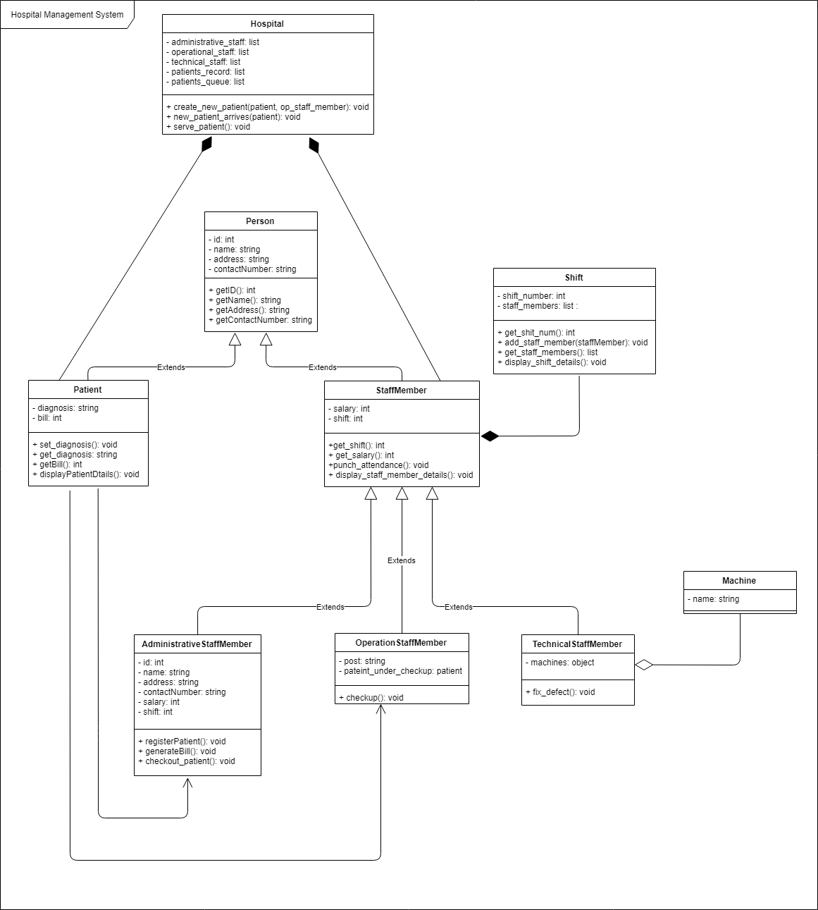

# **SOURCE CODE:**

import datetime, time, random

class Hospital:

def __init__(self, administrative_staff: list, operational_staff: list, technical_staff: list):

self.administrative_staff = administrative_staff

self.operational_staff = operational_staff

self.technical_staff = technical_staff

self.patients_record = {}

self.patients_queue = []

def create_new_patient(self, patient, op_staff_member):

self.patients_record[patient] = op_staff_member

def new_patient_arrives(self, patient):

admin_staff_member = random.choice(self.administrative_staff)

op_staff_member = random.choice(self.operational_staff)

admin_staff_member.register_patient(self, patient, op_staff_member)

self.patients_queue.append(patient)

return

def serve_patient(self):

patient = self.patients_queue.pop(0)

staff_assigned = self.patients_record[patient]

staff_assigned.checkup(patient)

self.patient_leaves(patient)

def patient_leaves(self, patient):

admin_staff_member = random.choice(self.administrative_staff)

admin_staff_member.checkout_patient(patient)

class Shift:

shift_number = None

staff_members = []

def __init__(self, shift_number):

if shift_number < 0:

shift_number = -shift_number

self.shift_number = (shift_number + 3) % 3

# self.staffPerShift = staffPerShift

def get_shift_num(self):

if self.shift_number == 1:

print("Shift 1. 7AM to 3PM")

elif self.shift_number == 2:

print("Shift 2. 3PM to 11PM")

elif self.shift_number == 3:

print("Shift 3. 11PM to 7AM")

return self.shift_number

def add_staff_member(self, staff_member):

self.staff_members.append(staff_member)

def get_staff_members(self):

return self.staff_members

# Display Shift

def display_shift_details(self):

print("Shift {}".format(self.shift_number))

for v in self.staff_members:

v.displayStaffMemberDetails()

class Person:

def __init__(self, person_id, name, address, contact_number):

self.person_id = person_id

self.name = name

self.address = address

self.contact_number = contact_number

def get_id(self):

return self.person_id

def get_name(self):

return self.name

def get_address(self):

return self.address

def get_contact_number(self):

return self.contact_number

class Patient(Person):

def __init__(self, patient_id, name, address, contact_number):

super(Patient, self).__init__(patient_id, name, address, contact_number)

self.diagnosis = ""

self.bill = 0

def set_daignosis(self, diagnosis):

self.diagnosis = diagnosis

def set_bill(self, bill):

self.bill = bill

def get_diagnosis(self):

return self.diagnosis

def get_bill(self):

return self.bill

def display_patient_details(self):

patient_details = ""

patient_details += str(self.get_id()) + '\t'

patient_details += self.get_name() + '\t'

patient_details += self.get_address() + '\t'

patient_details += str(self.get_contact_number()) + '\t'

patient_details += self.get_diagnosis() + '\t'

patient_details += str(self.get_bill())

return patient_details

# print(patient_details)

class StaffMember(Person):

def __init__(self, staff_id, name, address, contact_number, salary, shift: Shift):

super(StaffMember, self).__init__(staff_id, name, address, contact_number)

self.salary = salary

self.shift = shift

def get_salary(self):

return self.salary

def get_shift(self):

return self.shift

def punch_attendance(self):

if self in self.shift.get_staff_members():

return

self.shift.add_staff_member(self)

print("Attendance marked. Added to shift {}.".format(self.get_shift().get_shift_num()))

def display_staff_member_details(self):

details = ""

details += str(self.get_id()) + '\t'

details += self.get_name() + '\t'

details += self.get_address() + '\t'

details += str(self.get_contact_number()) + '\t'

details += str(self.get_salary()) + '\t'

details += str(self.shift.get_shift_num()) + '\t'

print(details)

class AdministrativeStaffMember(StaffMember):

def __init__(self, staff_id, name, address, contact_number, salary, shift):

super(AdministrativeStaffMember, self).__init__(staff_id, name, address, contact_number, salary,

shift)

def register_patient(self, hospital: Hospital, patient, operational_staff_member):

hospital.create_new_patient(patient, operational_staff_member)

print("Patient: {} registered by {}.".format(patient.get_name(), self.get_name()))

return

def generate_bill(self, patient):

disease1 = "Cancer"

disease2 = "Diabetes"

disease3 = "Fever"

if disease1 in patient.diagnosis:

patient.set_bill(20000)

elif disease2 in patient.diagnosis:

patient.set_bill(4000)

elif disease3 in patient.diagnosis:

patient.set_bill(1000)

print("Bill generated for patient {}. Generated by: {}".format(patient.get_name(), self.get_name()))

def checkout_patient(self, patient):

self.generate_bill(patient)

class OpeationalStaffMemeber(StaffMember):

def __init__(self, staff_id, name, address, contact_number, salary, shift, post):

super(OpeationalStaffMemeber, self).__init__(staff_id, name, address, contact_number, salary, shift)

self.post = post

self.patient_under_checkup = None

def checkup(self, patient):

print("Treatement started b {} {}. Patient details: {} \n".format(self.post,

self.get_name(),

patient.display_patient_details()))

diseases = ["Cancer", "Diabetes", "Fever"]

disease = random.choice(diseases)

patient.set_daignosis(disease)

print("Patient: {}. Disease diagnosed: {}".format(patient.get_name(), disease))

class Machine:

def __init__(self, name):

self.name = name

class TechnicalStaffMember(StaffMember):

def __init__(self, staff_id, name, address, contact_number, salary, shift, machines):

super(TechnicalStaffMember, self).__init__(staff_id, name, address, contact_number, salary, shift)

self.machines = machines

def fix_defect(self):

for machine in self.machines:

print("Fixing defect of {} machine.".format(machine.name))

time.sleep(1)

# **CONCLUSION:**

The case study was helpful to learn relationships between classes and strengthened understanding of core concepts of object oriented programming i.e. inheritance, encapsulation, aggregation, composition and association.

**PROBLEMS FACED:**

Finding out correct relationships between classes and their interlinking between one another.

**FUTURE EXPANSION:**

Designing a real-time hospital management application linked to a database.